 Sri Meenakshi Govt.Arts College for Women (A),

Madurai - 625 002

 Department of Physics

Naan Mudhalvan Scheme

Domain : Sales Force Associate

Project Tile : Vehicle Management System Using Salesforce

Submitted by

TEAM 1

Team Lead : Ms. Jeyashree.J

Team Member 1 : Ms. Lavanya.M

Team Member 2: Ms. Lavanya.P

Team Member 3 : Ms. Kaleeshwari.G

Mentors : Dr. K. Vijaya Kumar & Dr. P. Indra Devi

Assistants Professors, Department of Physics, Sri Meenakshi Govt.Arts College for Women, Madurai

April, 22 - 2023

**PROJECT REPORT TEMPLATE**

**1 INTRODUCTION**

**1.1 OVERVIEW**

Vehicle Management is an application where a customer Details are stored inorder to choose cars, bikes and commercial vehicles for travel with in the city. The data which is stored here is further used to remind them if any offers are provided during the seasons and any updates regarding vehicles are sent to them in the form of messages and mails.

Vehicle Management System is a windows application written for 32-bit Windows operating systems which focused in the area of adding, editing and deleting the passengers, staff and the bus routes. In this software a person can be register as a user and he can manage the bus routes and the staff, passengers' details.

**1.2 PURPOSE**

The Vehicle Management System (VMS) is an application for the Automative industry. It supports, in the area of Sales & Services, the business processes that you require as vehicle importer when dealing with your original equipment manufacturers (OEMs) and your dealers in new and used vehicle sales.

A vehicle management system is a software system — or platform — that serves to manage commercial fleets of vehicles, such as cars, vans or trucks — or even heavy equipment — to ensure they're utilized safely, efficiently and professionally, while making sure they're well maintained and high-performing.

**2 PROBLEM DEFINITION & DESIGN THINKING**

**2.1 EMPATHY MAP**

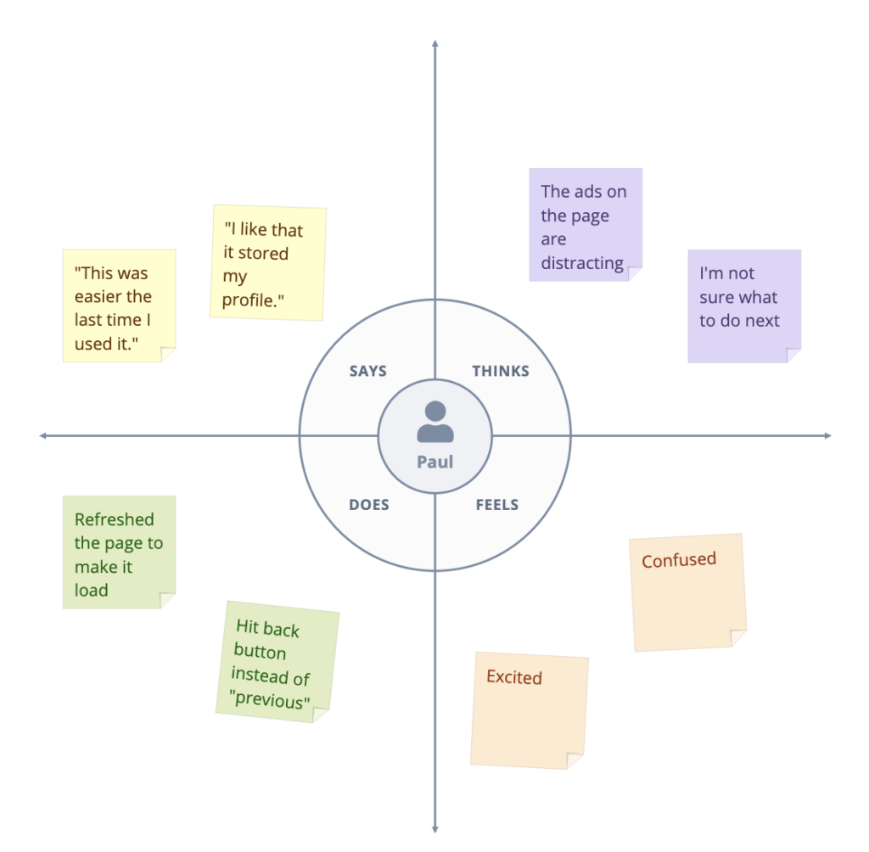

**2.2 IDEATION& BRAINSTORMING MAP** 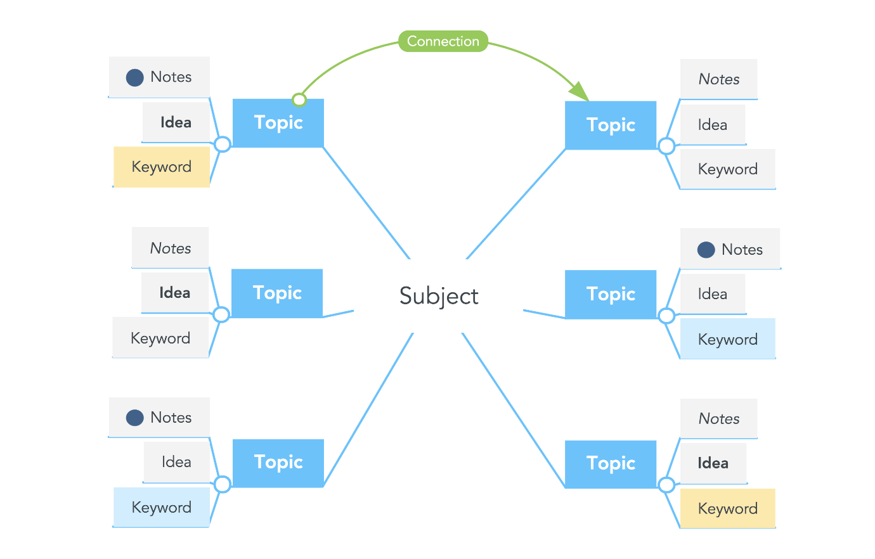

**RESULT**

**3.1 DATA MODEL:**

|  |  |  |  |  |  |  |  |
| --- | --- | --- | --- | --- | --- | --- | --- |
| Obj 1  Vehicle | |  |  | | --- | --- | | Field label | Data type | | Customer Name | Text | | Customer Mobile | Number | |
| Obj 2  Driver | |  |  | | --- | --- | | Field label | Data type | | Driver Name | Text | | Mobile No | Number | |

**3.2 ACTIVITY & SCREESHOT**

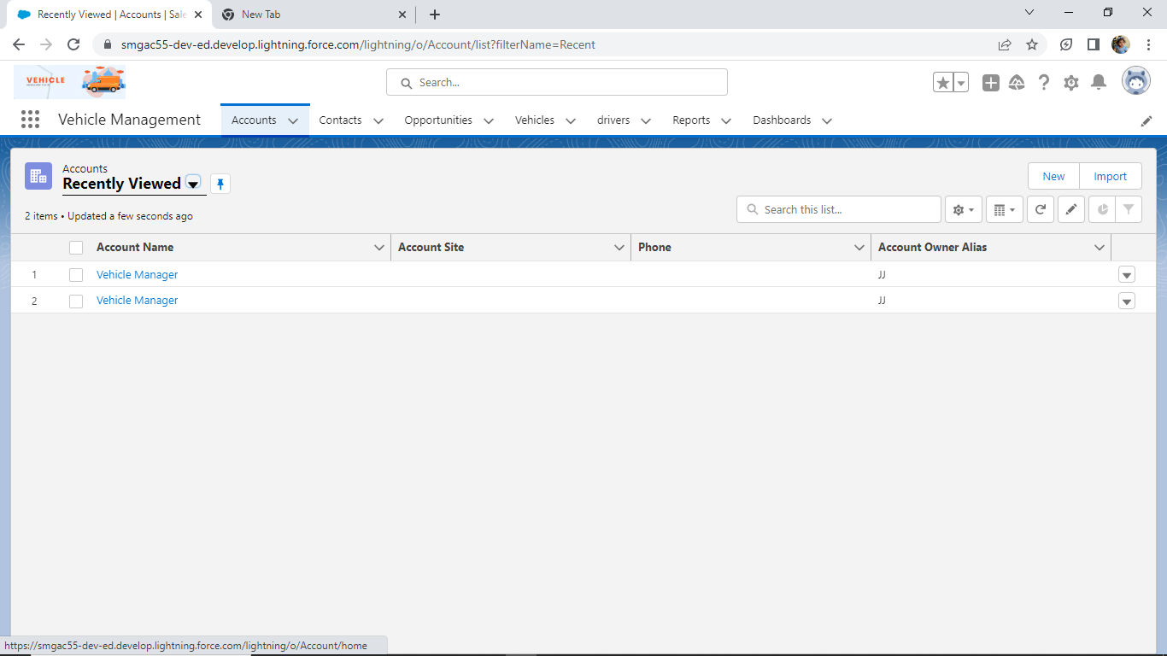

**DESCRIPTION**

In Salesforce, you use accounts to store information about the customers or people you do business with. There are two types of accounts: Business accounts. As the name implies, business accounts store information about the companies you do business with.

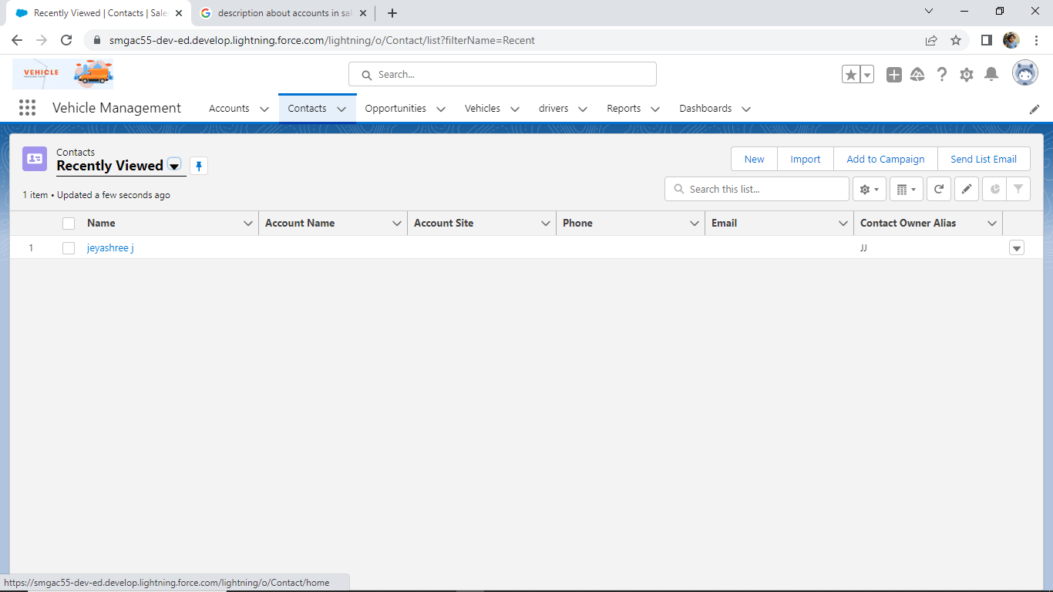

**DESCRIPTION**

Contact management is the act of storing, organizing, and tracking information about your customers, prospects, and sales leads. In its most basic form, you can manage your contact data using an address book or an Excel or Google spreadsheet with entries for all the people you do business with.

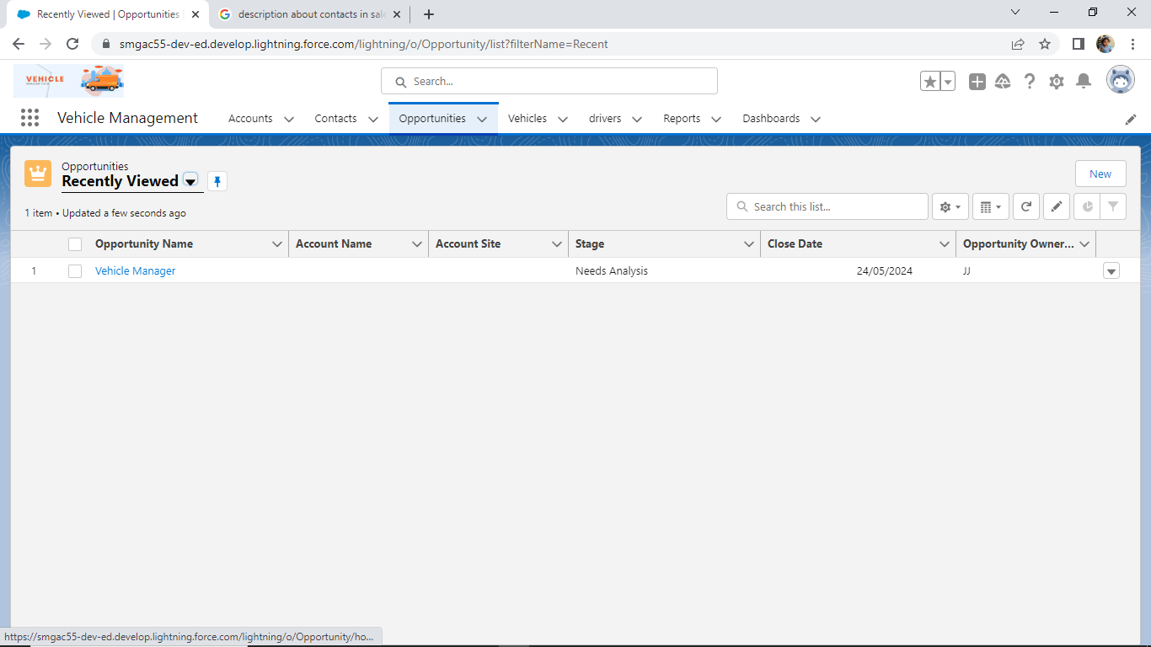

**DESCRIPTION**

Opportunities are deals in progress. Opportunity records track details about deals, including which accounts they're for, who the players are, and the amount of potential sales. If your Salesforce admin has set up leads in your Salesforce org, an opportunity is created when a lead is converted.

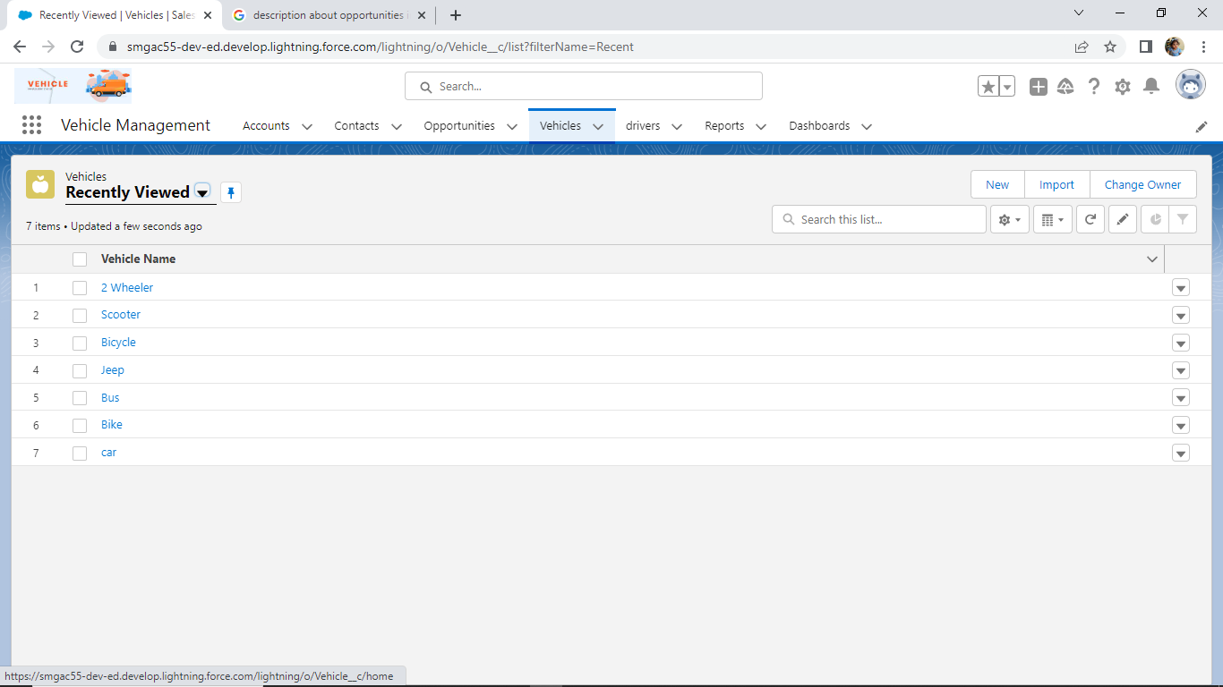

**DESCRIPTION**

From the App Launcher, find and select Vehicles, and then click New. Enter a name and description for the vehicle. Select a vehicle type. Enter either the license plate or vehicle registration number.

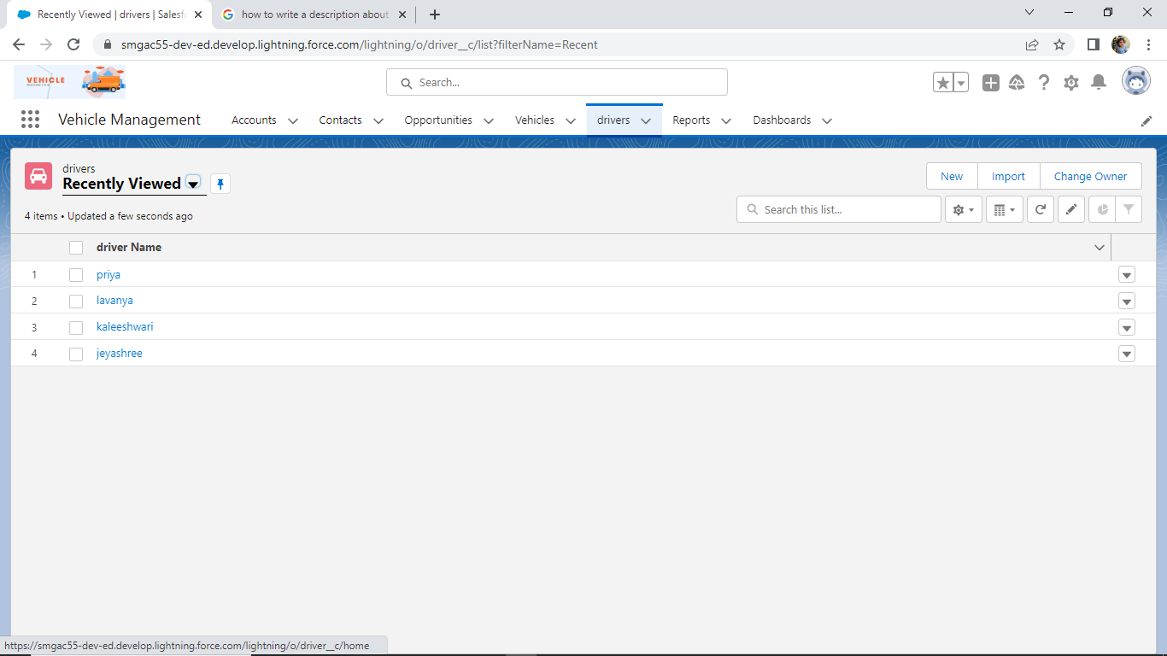

**DESCRIPTION**

The driver translates the SQL statements provided by the application to Salesforce queries (SOQL) and Web service calls. See [SQL Statements and Extensions for the Salesforce Driver](https://docs.progress.com/bundle/datadirect-connect-odbc-71/page/SQL-Statements-and-Extensions-for-the-Salesforce-Driver.html#SQL-Statements-and-Extensions-for-the-Salesforce-Driver) for the SQL statements that the driver supports.

The driver maps the Salesforce data model into a set of related relational tables. The mapping representation is stored in XML files external to the driver. This allows the sharing of map files among different client machines.

The driver uses a client-side data cache for improved performance. You can define rules that specify which data to cache on the client as well as when the cached data becomes invalid and needs to be refreshed (see [Client-Side Caches](https://docs.progress.com/bundle/datadirect-connect-odbc-71/page/Client-Side-Caches.html#Client-Side-Caches) for details).

The Salesforce driver can be used with industry standard tools, which means that developers can leverage their existing SQL knowledge instead of having to learn the Salesforce query language and APIs.

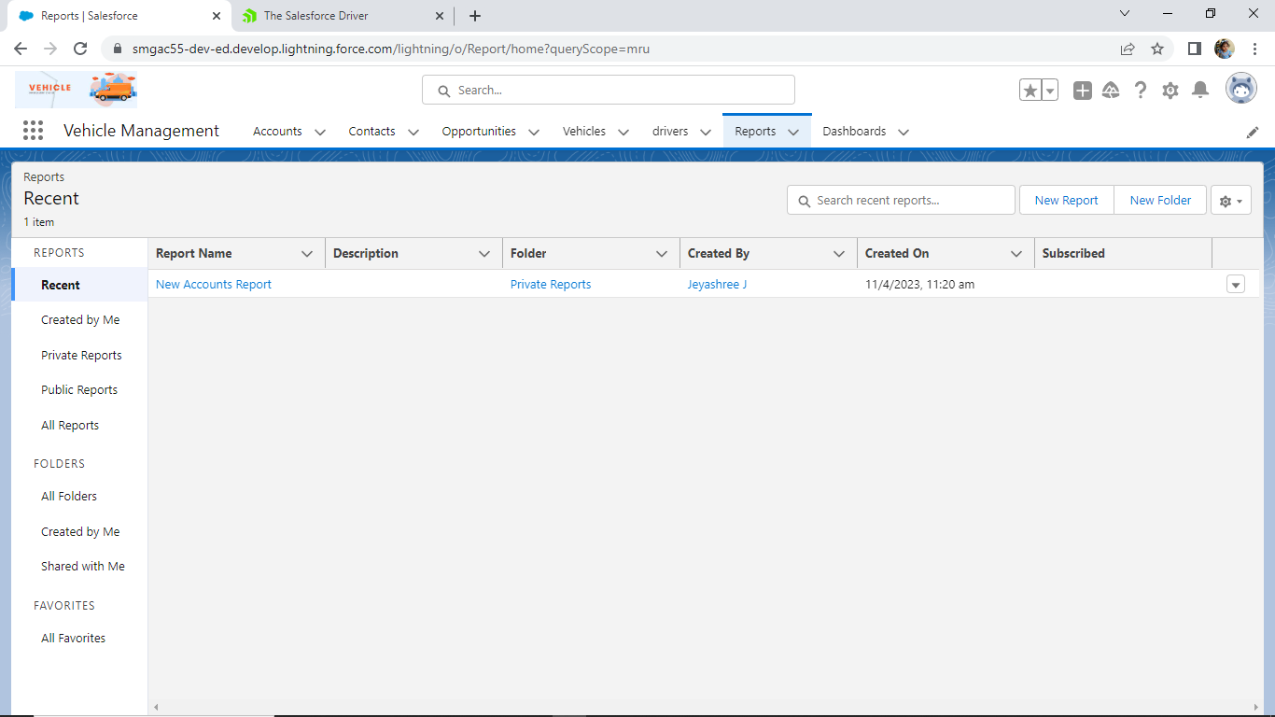

**DESCRIPTION**

A report is a list of records that meet the criteria. It’s displayed in Salesforce in rows and coloumns, and can be filtered, grouped, or displayed in a graphical chart. Every report is stored in a folder. Folders can be public, hidden, or shared, and can be set to read only or read/write.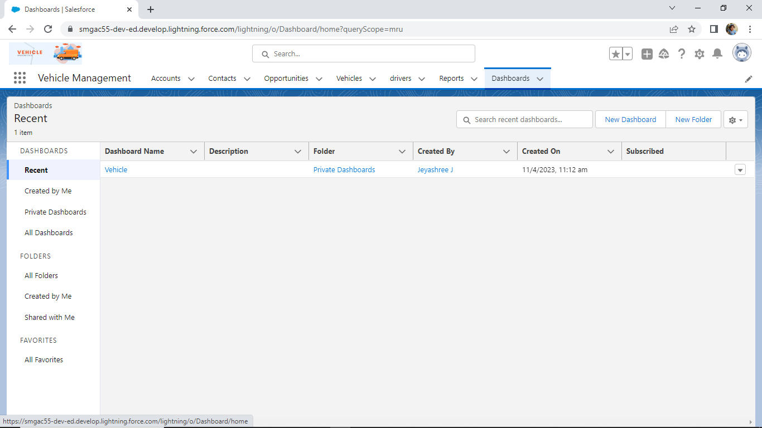

**DESCRIPTION**

Salesforce Dashboard is a simple way to visualize key data from either one or multiple Salesforce reports, and can help to “identify trends, sort out quantities, and measure the impact of their activities”.

**4 TRAILHEAD PROFILE PUBLIC URL**

Team Lead -<https://trailblazer.me/id/jeyaj>

Team Member 1-<https://trailblazer.me/id/lavanyamari29>

Team Member 2-<https://trailblazer.me/id/lavanyap2003>

|  |  |  |  |  |
| --- | --- | --- | --- | --- |
| |  | | --- | | Team Member 3 -<https://trailblazer.me/id/kaleeshwari5112> | |  |  | https://mail.google.com/mail/u/0/images/cleardot.gif  https://mail.google.com/mail/u/0/images/cleardot.gif |
| PROJECT REPORT TEMPLATE | | |

**5 ADVANTAGES & DISADVANTAGES**

|  |  |  |
| --- | --- | --- |
| |  | | --- | | 1. Low fuel consumption. 2. Tracking in real-time. 3. Safe and secure. 4. GPS vehicle tracking through mobile app. 5. Vehicle maintenance and management. 6. Control of fuel consumption. 7. Driver safety and management.   8 Dispatch management.  DiDispatcnageenowjfn88888gndividualized reports for all parties involved | |  |

**DISADVANTAGES**

|  |  |
| --- | --- |
| They're expensive to buy, maintain and insure. They emit air pollution that can harm your health. They contribute to global warming and climate change. They cause accidents and injuries when they run people over or collide with other vehicles on the road.  **6**  **APPLICATIONS**  The Vehicle Management System (VMS) is an application for the Automotive industry. It supports, in the area of Sales & Services, the business processes that you require as vehicle importer when dealing with your original equipment manufacturers (OEMs) and your dealers in new and used vehicle sales.  A vehicle management system is a software system — or platform — that serves to manage commercial fleets of vehicles, such as cars, vans or trucks — or even heavy equipment — to ensure they're utilized safely, efficiently and professionally, while making sure they're well maintained and high-performing.  **7 CONCLUSION**  Our project is only a humble ventor satisfy to needs to manage their project work. Several user friendly coding have also adopted. This package shall prove to be a powerful package in satisfying all the requirements of the school. The objective of software planning is to provide a frame work that enables the manager to make reasonable estimates made within a limited time frame at the beginning of the software and should be updated regularly as the project progresses. |  |

**8 FUTURE SCOPE**

In a nutshell, it can be summarized that the future scope of the project circles around maintaining information regarding;

* We can add printer in future.
* We can give more advance software for vehicle management system including more facilities.
* We will host the platform on online servers to make it accessable worldwide.
* Integrate multiple load balancers to distribute the loads of the system.
* Create the master and slave database structure to reduce the overload of the database queries.
* Implement the backup mechanism for taking backup of codebase and database on regular basis on different servers.

The above mentioned points are the enhancements which can be done to increase the applicability and usage of this project. Here we can maintain the recodes of vehicle and driver. Also, as it can be seen that now-a-days the players are versatile, so there is a scope for introducing the method to maintain the vehicle management system. Enhancement can be done to maintain all the vehicle, driver, maintenance,

Fuel.

We have left all the options open so that if there is any other future requirement in the system by the user for the enhancement of the system then it is possible to implement them. In last we would like to thanks all the persons involved in the development of the system directly or indirectly. We hope that the project will serve its purpose for which it is develop there by underlining success of process.

|  |  |
| --- | --- |
| |  | | --- | | https://mail.google.com/mail/u/0/images/cleardot.gif | |

|  |  |
| --- | --- |
|  |  |

|  |  |  |  |  |  |
| --- | --- | --- | --- | --- | --- |
| |  | | --- | |  | | 1 | |  | https://mail.google.com/mail/u/0/images/cleardot.gif  https://mail.google.com/mail/u/0/images/cleardot.gif |
|  |  | |  |
| |  | | --- | | https://mail.google.com/mail/u/0/images/cleardot.gif | | |  |

|  |  |  |  |  |
| --- | --- | --- | --- | --- |
| |  | | --- | |  | |  |  | https://mail.google.com/mail/u/0/images/cleardot.gif  https://mail.google.com/mail/u/0/images/cleardot.gif |
| |  | | --- | | https://mail.google.com/mail/u/0/images/cleardot.gif | | | |

|  |  |  |  |  |
| --- | --- | --- | --- | --- |
| |  | | --- | |  | |  |  | https://mail.google.com/mail/u/0/images/cleardot.gif  https://mail.google.com/mail/u/0/images/cleardot.gif |
| |  | | --- | |  | | | |